Version: 1.0
7 July 2023

REDSPICE EOI Part2 information

Background

REDSPICE: Resilience – Effects – Defence – SPace – Intelligence – Cyber – Enablers
REDSPICE is the most significant single investment in the Australian Signals Directorate’s 75 years. It responds to the deteriorating strategic circumstances in our region, characterised by rapid military expansion, growing coercive behaviour and increased cyber-attacks.
Through REDSPICE, ASD will deliver forward-looking capabilities essential to maintaining Australia's strategic advantage and capability edge over the coming decade and beyond.
ASD has engaged Keane Consulting (Keane) through the ASD Technical Support Services (TSS) Panel to support REDSPICE in identifying and engaging long term contractors to deliver the REDSPICE initiatives and meet its goals.
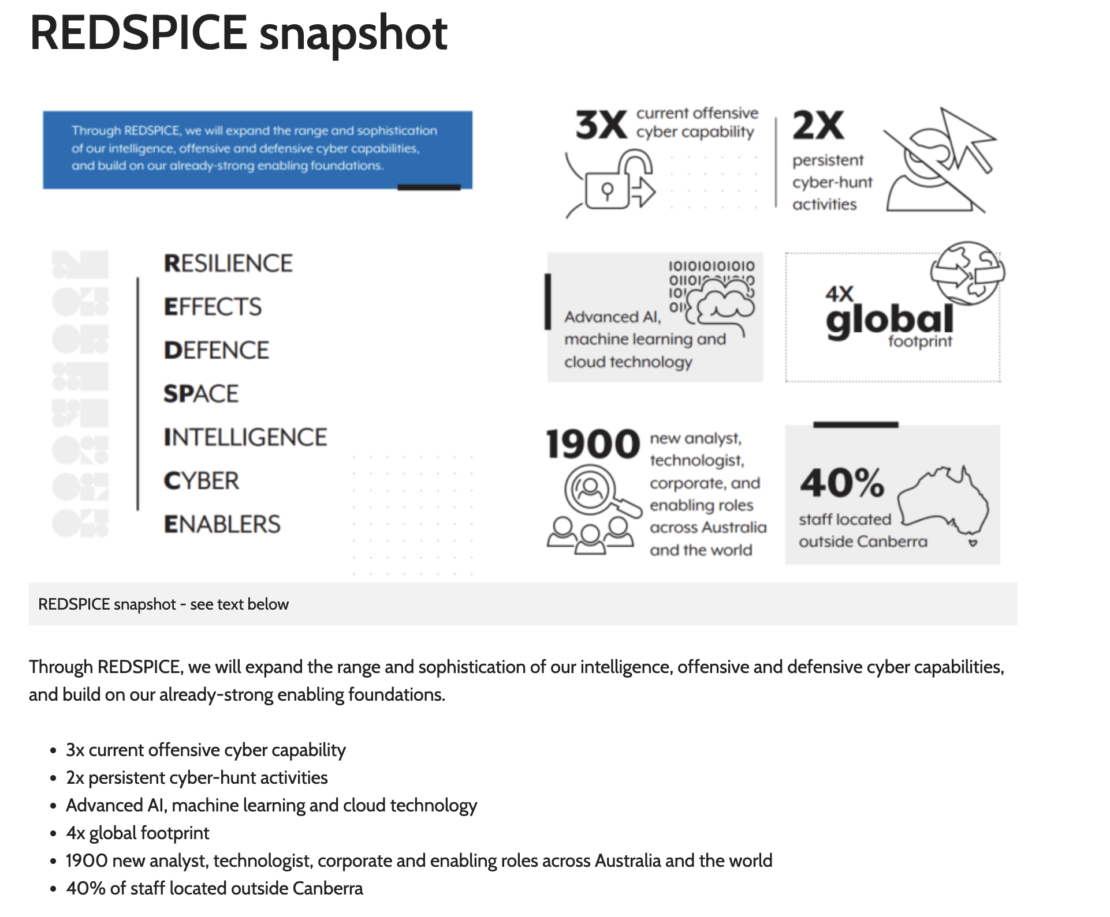

EOI Part 1&2
The Expression of Interest (EOI) Part 1 included ASD requesting Keane provide its approach to supporting the REDSPICE program. The Keane approach was accepted on 6 July and ASD subsequently requested Keane provide suitable resources to be evaluated as part of the EOI Part 2.

ASD Requirements
As part of EOI Part 2 ASD require Keane to provide resources to fulfill the following key roles in Melbourne and Brisbane.
Candidates must either have a current or previous TSPV clearance or be willing and able to obtain one through this recruitment process.
The key roles for Part 2 are:
- Business Analyst
- ICT Security Specialist
- Network Engineer
- Project Manager
- Project Support Officer
- System Administrator
- Software Engineer / Developer
Candidates who are assessed as being suitable to fulfil a role through this evaluation process will be required to undertake the OSA (Organisation Suitability Assessment) and PV process.

Candidate Submissions
In order to apply for one of these roles we require the following from you:
- Completion of the “Keane candidate information” spreadsheet
- A resume/CV (maximum of two pages which provides:
  - qualifications and capabilities background
  - expertise and experience performing in similar roles
  - Telephone detail of supervisor/ referee with currency within the last 12months.
The above information will be treated in the strictest confidence and will only be used by Keane and ASD for the purposes of evaluating potential contractors to put into the OSA> PV pipeline.

EOI Part 2 Closes
Please email the information required above to admin@keane.com.au and/or the Keane Recruitment Consultant you have been working with by Friday 4 August 2023

